**Message from Principal**

Dear Parents.

My name is Arjumand Zaidi and I have the honor of having assumed as Principal of Al Shoumoukh International Academy – Qatar, I have included brief details of my educational background, and certificates in the end.

I believe in holding high expectations for all my staff, students and parents. I am committed with assisting them to meet high expectations. Through our daily interactions, we will learn and prove that we are one team. I will appreciate parents to be a part of this team which is meant to develop our students into globally aware citizens entrenched in their Islamic values.

I also want to ensure a good discipline in school where children feel safe and happy along with learning life skills based on our Islamic values and culture. In addition to regular classwork, and projects, we will be expecting all homework assigned during the day to be completed and we will be extending help to make learning a meaningful experience for all. I encourage you to ask questions and raise any concerns. My primary goal is to keep all students and teachers engaged in learning.

In closing, I would like to express that one of the most important aspects of our relationship is to keep the lines of communication open. Positive ad productive communication is paramount to our success at school. If you have any questions or concerns during the year, please don’t hesitate to seek an appointment with me. I welcome you all and I am willing to listen about your views, ideas and concerns. Thank you for your trust in Al Shoumoukh International Academy.

**Principal**

**Arjumand Zaidi**

|  |
| --- |
| Arjumand Zaidi  Principal, Al Shoumoukh International Academy  44424220 / 66633052 [zaidi_in_2006@yahoo.com](mailto:zaidi_in_2006@yahoo.com)  [www.sia.sch.qa](http://www.sia.sch.qa)  Al Shoumoukh International Academy-Rawdat-Al Hamam P.O Box 45872 Doha,Qatar |

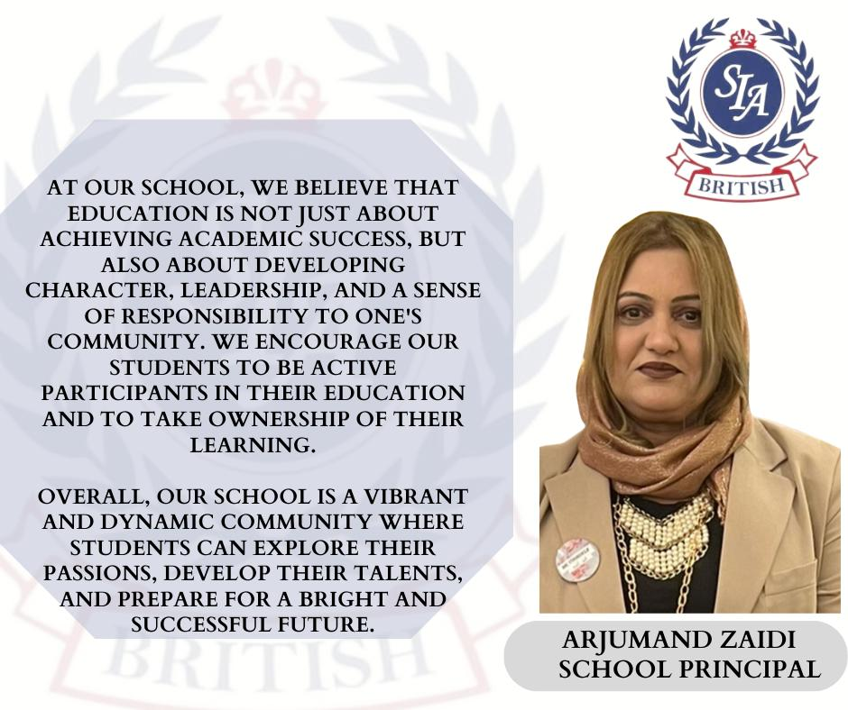

**Arjumand Zaidi**

**Academic Qualifications:**

* **(Learning Teaching) Department of Education, Oxford University, attended course in Islamabad, Pakistan.**
* **Got an elaborated management course hosted by Development Foundation of Pakistan.**
* **Attended workshop on Jolly Phonics by the Co-Author Sue Lloyd from Jolly Learning LTD. Doha, Qatar.**
* **Got Teaching and management training from Korea.**
* **Got Pre and Primary Teaching training from Seeds, Pakistan.**
* **Attended teachers and management’s training courses under the name of Intel Teach to the Future Program.**
* **Master’s Degree in Political Science**
* **Bachelor’s Degree in Education.**

**Professional Experience: 31 years**

* **2023- to date: Principal SIA**
* **2006 – 2022: Head of Kg Section**
* **2000 – 2005: Principal, Springfield school, Pakistan**
* **1992 – 2000: V ice Principal, Silver oaks school, Pakistan.**

**--------------------------------------------------**